Hard Pine Stem Rusts
Medium to Low priority
2 and 3 needle pine, Pli, Py | Commandra Blister Rust (Cronartium comandrae) DSC
Pli, Py | Stalactiform Blister Rust (Cronartium coleosporioides) DSS
Pli, Py | Western Gall Rust (Endocronartium harknessii) DSG

Description

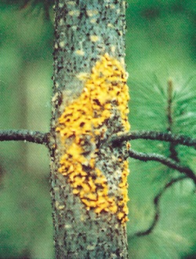
Commandra blister rust is primarily a disease of young lodgepole pine. The primary hosts are 2- and 3-needle pines, and the alternate host is primarily bastard toadflax. The fungus is an obligate parasite and the host often does not show crown symptoms until just before death. Most stem cankers are lethal, occurring within 1 m of the ground and often beginning as branch infections. Branch cankers appear as blunt-ended swellings that girdle the branch, whereas stem cankers are oval or diamond-shaped. For most of the year cankers are inconspicuous. In the spring, blisters appear and release orange spores, which infect the alternate host. Spores returning from the alternate host infect pine needles in the late summer. Lower branches should be carefully inspected for cankers. Most tree mortality occurs between ages 5 and 30. The uneven distribution of mortality often leads to stand gaps. Squirrels commonly feed on cankers and may hasten host mortality.

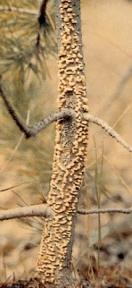
Stalactiform blister rust primary hosts are lodgepole and ponderosa pine, and the alternate hosts include Indian paintbrush (Castilleja spp.) and other species of the figwort family (Scrophulareacea). Trees of all ages can be infected but mortality occurs primarily on small or slow-growing trees. The fungus is an obligate parasite and the host often does not show crown symptoms until just before death. The disease causes a bark canker which is often lethal when located on the stem. Cankers appear as elongated swellings that slowly girdle the branch or stem. Cankers are diamond-shaped and typically 10 times higher than wide. Stem cankers can be several metres in length. In the spring, blisters appear and release orange spores which infect the alternate host. Spores returning from the alternate host infect pine needles in the late summer. Mortality occurs rapidly on very young trees. Due to the slow growth of stalactiform cankers, large infected trees will survive to a commercial thinning or harvest but will suffer increment loss and reduced wood quality. Canker edges are often fed upon by squirrels. Repeated feeding on cankers can result in a striated pattern of bark stripping. Spike tops on older trees result when live crown exists below the canker.

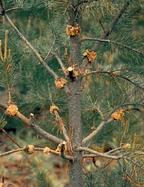
Western gall rust primary hosts are lodgepole and ponderosa pine. Western Gall Rust produces round woody swellings on stems and branches. Orange spores are produced on galls in late spring. These spores directly infect other pines through elongating leaders and branch shoots. Suitable climatic conditions that occur every few years result in "wave years" of infection. The fungus is an obligate parasite and remains alive as long as the host branch or stem. However, infections stop releasing spores after about age 10. Most stem infections occur below a height of 3 m. Hip cankers result in distorted growth from partial stem girdling. Infected bark can be fed upon by squirrels. Western gall rust is very common throughout the range of lodgepole pine. Stem galls often lead to mortality either through girdling or through stem breakage. Branch galls do not cause serious harm. The disease is usually more evenly distributed throughout stands than blister rusts, which require an alternate host.

Extent
Hard pine stem rusts are currently considered a moderate priority forest health factor in the Bulkley and Cassiar TSAs. They can result in significant losses in pine, particularly on those stems in the seedling to pole size range. It is likely that these losses have been accounted for in the current operational adjustment factors. However, hard pine stem rusts are becoming more prevalent in areas previously considered as low hazard. Stands in the vicinity of Tzezakwa Creek on the 4000 Road have been hit particularly hard recently, with incidence levels greater than 50% in some cases. However, the cause behind the distribution of severely damaged stands within the district is not well understood. It is possible that with climate change, this district will experience wetter summers – a likely precursor to higher incidence levels of hard pine stem rusts. Thus, it may be necessary to look at planting alternate species to reduce plantation risk.
In the Kispiox TSA, hard pine stem rusts were historically of very minor concern. Since the advent of Dothistroma and the reduction in the significance of lodgepole pine for the future timber supply, the hard pine rust risk has been reduced even more in significance.

Data
*See map at end of this section

Tactics
- To reduce losses of volume and mortality in young lodgepole pine stands impacted by rusts, and to prevent similar stand management situations from occurring in the future.
- Hard pine stem rust management in the Bulkley TSA should conform to those tactics outlined in the Pine Stem Rust Management Guidebook. http://www.for.gov.bc.ca/tasb/legsregs/fpc/fpcguide/PINESTEM/PINE-TOC.HTM
- The District has created a High Risk Rust Area Map to assist in identifying known high rust risk areas within the district.
- In high risk areas where there is a history of significant rust damage, or in areas where the rust incidence is increasing, additional care must be taken when developing planting regimes. Maximizing species diversity through the planting of non-host species is the most effective means of managing this forest health factor.
- Do not juvenile space lodgepole pine stands in high risk areas.
- Ensure that surveyors are fully versed in the identification of rusts and the rust survey standards. Conduct silviculture surveys during the sporulation window (June thru July).
- Any pine leading plantations submitted for FG declaration with 5% total rust incidence or greater, and less than 10 years old will be reviewed by the District.
- The District will run a forest health query from RESULTS, and build a list of known rust affected plantations. A monitoring plan will be established to revisit known rust affected stands, and build a better understanding regarding long term rust risks for the district.
- These suggestions are backed by the Northern Interior Regional Pathologist and recorded in FREP report #13 “Are Free-Growing Stands Meeting Timber Productivity Expectations in the Lakes Timber Supply Area?” http://www.for.gov.bc.ca/hfp/frep/publications/reports.htm#rep13
                - The following Mapsheets are known to contain young Pine stands with considerable Stem Rust infections. Surveys or treatments therein will follow the guidelines laid out in the previous Strategies.

93L 064 | 93L 074 | 93L 088 | 93M070
93L 066 | 93L 076 | 93L 092
93L 072 | 93L086 | 93M008
93L 073 | 93L 087 | 93M043

